  - POLICIES & PROCEDURES
STUDENT HANDBOOK

NSW Fishing Industry Training Committee Ltd
  - POLICIES & PROCEDURES

Welcome
Thank you for choosing NSW Fishing Industry Training Committee Ltd , we look forward to working with you to achieve your training and career goals.
NSW Fishing Industry Training Committee Ltd is committed to providing high quality standards of vocational education and training, we aim to provide a happy, friendly atmosphere in which to learn.
NSW Fishing Industry Training Committee Ltd will ensure that you will receive the opportunity to fulfil your personal potential during your training and every endeavour will be made by staff to accommodate the training to meet your individual needs.
It is important to keep this handbook on hand during your training, as it will provide additional guidance as you progress throughout your training. In this handbook, you will find information about NSW Fishing Industry Training Committee Ltd ’s policies and procedures, together with forms and documents that you may need to refer to and/or complete.
If you have any suggestions on how we can improve our Policies and Procedures, please complete an “Opportunity for Improvement” form and submit to the RTO Manager.
We sincerely hope your time at NSW Fishing Industry Training Committee Ltd is a memorable and productive learning experience.
If you require any assistance with understanding these Policies and Procedures, please do not hesitate to ask your trainer for assistance, who can explain the process further.
  - Contact details
Phone: (02) 4344 1366
Email: nsw.fitc@optusnet.com.au
Web: www.maritimesafetytraining.com.au
Address: Suite 7 11-13 The Boulevard Centre Woy Woy
NSW 2256
RTO ID: 90440

1 Welcome 1
2 Code of Conduct (T&S) 4
3 Student Responsibilities 6
4 Enrolment Agreement Form 6
5 Enrolment and Selection 7
5.1 Support Services Process 7
5.2 Information Session 7
6 Course Fees, Payments, Refunds and Certification 8
6.1 Cooling Off Period 8
6.2 Payment Plan 8
7 Consumer Guarantee 9
7.1 What happens if this guarantee is not met? 9
8 Changes to Agreed Services 9
8.1 Changes to Agreed Services Process 10
9 Training Evaluation Form 10
10 Language, Literacy and Numeracy (LLN) 11
10.1 LLN Assessment Process 11
10.2 Monitoring the Effectiveness of Services 11
11 Support Services 12
11.1 Support Services Form 12
11.2 Support Services List 13
12 Principles of Assessment and the Rules of Evidence 13
12.1 Assessment Cover Sheet 14
13 Recognition of Prior Learning (RPL) 14
13.1 RPL Kit 15
14 Cheating and Plagiarism 15
14.1 Definition of Cheating 15
14.2 Definition of Plagiarism 15
14.3 Penalties 16
14.4 What if I don’t agree with the decision? 16
15 Opportunity for Improvement 17
16 Certification 18
18 Credit Transfer 18
19 Unique Student Identifier 19
19.1 Do you need a USI? 19
19.2 Enrolment Process for USI 19
19.3 Security of the Student USI 20
19.4 USI Privacy Notice 20
19.5 Issuance of recognised qualifications or statements of attainment 20
20 Complaints Policy 20
20.1 Complaints Process 21
20.2 Complaints Flowchart 22
20.3 Complaints and Appeals Form 22
20.4 Complaints Report Form 22
20.5 Complaints and Appeals Register 22
21 Assessment Appeals Policy 23
21.1 Assessment Appeals Procedure 23
22 Fee Protection Policy 24
22.1 Threshold Prepaid Fee 24
23 Insurance 24
24 Legislative and Regulatory Requirements 25
24.1 Statutory Education Licence 25
24.2 Standards for Registered Training Organisations 2015 25
24.3 National Vocational Education and Training Regulator Act 2011 25
24.4 Australian Qualifications Framework (AQF) 26
24.5 Data Provision Requirements 2012 (T) 26
24.6 Privacy Protection Act 2012 & Privacy Act 1988 26
Australian Privacy Principle 1 – Open and transparent management of personal information 27
Types of information which will be collected and where it is held 27
How information is gathered 27
Australian Privacy Principle 2 – Anonymity and Pseudonymity 27
Australian Privacy Principle 3 – Collection of solicited personal information 27
Personal information other than sensitive information 27
Sensitive information 27
Australian Privacy Principle 4 – Dealing with unsolicited personal information 27
Australian Privacy Principle 5 – Notification of the collection of personal information 27
Australian Privacy Principle 6 – Use or disclosure of personal information 28
Australian Privacy Principle 7 – Direct marketing 28
Australian Privacy Principle 8 – Cross border disclosure of personal information 28
Australian Privacy Principle 9 – Adoption, use or disclosure of government related identifiers 28
Australian Privacy Principle 10 – Quality of personal information 28
Australian Privacy Principle 11 – Security of personal information 28
Australian Privacy Principle 12 – Access to personal information 28
24.7 Workplace Health and Safety Act 2011 28
WHS Incident Report 30
Hazard Identification 30
24.8 Emergency Procedures 31
Fire Emergency 31
Evacuation Procedure (T&S) 31
24.9 Anti-Discrimination Act 1977 31
24.10 Sexual Harassment Act 1984 32
24.11 Harassment Act 1997 32
24.12 Anti-Bullying 33
24.13 AFP National Police Check 33
24.14 Copyright Act 1968 34
24.15 Working with Children Check 34
Who needs a Working with Children Check? 34
24.16 Child Protection (Working with Children) Regulation 2013 34
25 Support Services List 1

Code of Conduct (T&S)
NSW Fishing Industry Training Committee Ltd is responsible for ensuring ongoing compliance with the Standards for Registered Training Oganisations, including where services may be delivered on the RTO’s behalf. The Chief Executive Officer is responsible for ensuring that the operations, staff and students of the RTO complies with the requirements of the VET Quality Framework, which includes the following:
- the Standards for Registered Training Organisations (RTOs) 2015
- the Australian Qualifications Framework
- the Fit and Proper Person Requirements 2011
- the Financial Viability Risk Assessment Requirements 2011
- the Data Provision Requirements 2012
NSW Fishing Industry Training Committee Ltd will ensure that compliance applies across all of its operations within the RTO’s scope of registration, as listed on the National Register (http://www.training.gov.au). (5.3)
NSW Fishing Industry Training Committee Ltd has policies and procedures in place for ensuring compliance with the VET Quality Framework, which are distributed to Staff and Students as part of their induction process, these policies and procedures include how the RTO will comply with the following:
Standards for Registered Training Organisations 2015
- Standard 1 – Training and Assessment
  - Learners benefit from high-quality training that equips them for employment and/or further study in their chosen field.
  - Learners are confident they hold the skills and knowledge their certification describes and are well-equipped to undertake relevant tasks safely and productively.
  - Graduates have enhanced employment prospects because employers are confident in their abilities.
- Standard 2 – Quality Assurance Strategies
  - Learners are confident that the quality of training is monitored to ensure it meets their needs and the needs of employers.
- Standard 3 - Certification
  - Learners receive certification that clearly documents their skills and knowledge in a timely manner.
- Standard 4 - Marketing
  - Learners can make informed choices that the RTO has training that meets their needs with clear and accurate information including information about the performance of the RTO
- Standard 5 – Students rights and obligations
  - Learners can make informed choices about the RTO and the training program that best suits their needs
  - Learners know who is delivering their training and who is issuing any qualification or statement of attainment
  - Learners are aware of their rights and responsibilities
- Standard 6 – Complaints and appeals
  - Learners have any concerns about their training or assessment addressed promptly and equitably
- Standard 7 - Governance
  - Learners know their provider is stable and well-governed, so are confident it will continue to operate and be properly resourced to deliver training
  - Learners know that their exposure to financial loss is limited in the case of a provider closing or not being able to provide the training
- Standard 8 – Compliance with legislation
  - Learners are assured that our RTO is monitored by a regulator that has accurate, up-to-date information about the provider
  - Learners are confident our RTO complies with relevant legislation and regulatory requirements
  - Learners are aware of requirements that relate to their training
  - Learners can make informed choices about the RTO using accurate and up-to-date information
Australian Qualifications Framework:
- Adhere to the requirements of the AQF Qualifications Issuance Policy
- Adhere to the requirements of the AQF Qualifications Pathways Policy
Fit and Proper Person Requirements
- All senior management, or persons who would have a significant impact on the RTO, are required to complete and submit a Fit and Proper Person form to the National VET Regulator
Data Provision Requirements
- Collect and store student and training records within an AVETMISS compliant Student Management System (DPR 4)
- Collect data on behalf of the National VET Regulator against the AVETMISS requirements (DPR 4.1)
- Collect data on behalf of the National VET Regulator against the Quality Indicators (DPR 6)
- Submit annual reports to the National VET Regulator on data collected (DPR 7)
Working with Children Check
- All Trainers and Assessors are required to undertake a Working with Children Check prior to commencing training and assessment if they will be delivering training and assessment to students under the age of 18 years.

Student Responsibilities
As a student with NSW Fishing Industry Training Committee Ltd , you are responsible for your own actions, this includes:
- Complying with the policies and procedures within the Student Handbook
- Participating in all training activities by asking questions and interacting with other students
- Communicating with the Trainer any struggles that you may be having, especially if it will affect your training and assessment.
- Thinking of the classroom as your workplace, are you are good work colleague?
- Dressing appropriately for the classroom, as if you would dress for your workplace
- Using your brain and challenge yourself in the classroom, you will thank yourself later when you have a better understanding of the training that was delivered
- Completing all assessment requirements required to determine your competency
- Cooperating with Trainers, Assessors, RTO Staff and Students in the conduct of training and assessment
- Pay all course fees prior to course commencement
- Finding ways to relate to your reading and writing. What original thoughts and experiences can you bring to the course to make it come alive for yourself?
- Being in the training, participate, don't jeopardise your own learning by not participating
- Surround yourself with other students who can help you. You don't have to be best friends with everyone you seek advice from, but find friends or acquaintances that will help you to be the best of you.

Enrolment Agreement Form
All students are required to complete an enrolment form prior to course commencement to ascertain contact details, Unique Student Identifier, course of interest, emergency contact details, whether there is any recognition of prior learning and to collect the relevant statistical information required for AVETMISS reporting.
The back of the enrolment form outlines the Terms and Conditions of enrolment, including student’s rights and responsibilities. Students are required to sign the back of the form to acknowledge their agreement with the RTO’s terms and conditions.
A copy of the Enrolment Agreement Form will be supplied to the learner, in line with the Australian Consumer Law requirements, prior to course commencement.
The RTO Manager is responsible for ensuring each student has completed an enrolment form prior to course commencement.
Following is a list of “Terms & Conditions of Enrolment” listed on the Enrolment Agreement Form:
- Enrolment and Selection (Clause 5.3)
- Consumer Guarantee (Clause 5.3)
- Course Fees, Payments and Refunds (Clause 5.3)
- Fee Protection (Clause 7.3)
- Cooling Off Period (Clause 5.3)
- Complaints and Appeals (Clause 6.1)
- Credit Transfer (Clause 3.5)
- Language, Literacy and Numeracy (Clause 1.7)
- Support Services (Clause 1.7)
- Legislative and Regulatory Requirements (Clause 8.5)
- Workplace Health and Safety (Clause 8.5)
The Enrolment Agreement Form includes:
- Confirmation that the RTO is responsible for compliance of training and/or assessment
- Confirmation that the RTO is responsible for issuance of AQF certification documentation
- Details of the RTO complaints and appeals processes (also refer Clauses 6.1 – 6.4)
- The leaner’s rights if the RTO or third party closes or ceases to deliver the agreed training and/or assessment
Each student is required to complete an enrolment form prior to course commencement. The form is to be signed by the student stating that they agree with the RTO’s policies and procedures, as outlined on the back of the enrolment form.

Enrolment and Selection
- The student is responsible for notifying NSW Fishing Industry Training Committee Ltd if they have a medical condition or disability or require assistance in their training.
- A deposit must accompany enrolment to secure a placement within a course; this fee is also the Administration Fee.
- It is the student’s responsibility to note the date, time and location of the course as advertised.
- Courses with low enrolments may be cancelled, every effort will be made to contact students, please ensure your contact details are correct.
- Requests from the student to transfer or credit their course placement due to changed personal circumstances will be considered and every effort will be made to ensure a placement into an alternative course.
- If you are unable to complete your course, due to changed personal circumstances, the RTO will make every effort to ensure you are placed into an alternative pre-scheduled course.
- Students can only join after course commencement date if they meet all prerequisites. Full course fees are still payable for late enrolments.
- The RTO reserves the right to decline admission to a course, terminate a student's enrolment in a class or change a Trainer/Assessor at any time without notice.
- Students participate in courses involving physical activity; field trips, practical demonstrations etc. and do so at their own risk. The RTO’s students are covered by public liability insurance whilst working within the RTO’s premises.
- If a student is identified as having a Disability and requiring further support, refer to the Support Services section in this manual.

Support Services Process

Information Session
An information session is offered to students to provide them with further information about the course to assist them with making an informed decision about enrolling into a course. The Information Session is only applicable for Full qualifications.

Course Fees, Payments, Refunds and Certification
- Please refer to the course flyer for information on course fees, including any required deposit; administration fees; materials fees and any other charges (if applicable).
- In line with the RTO’s Fee Protection Policy the RTO will not collect more than $1,500 prior to course commencement.
- Certificates and Statements of Attainment are issued to students who are assessed as competent in the units successfully completed. The cost of the certificates is included in the course fees.
- Refunds may be made in the following circumstances:
  - Participants have overpaid the administration charge
  - Participants enrolled in training that has been terminated by the RTO
  - Participant advises the RTO prior to course commencement that they are withdrawing from the course
  - If the participant withdraws from a course or program, prior to course commencement, due to illness or extreme hardship as determined by the RTO
  - In the event that the RTO fails to provide the agreed services
- A deposit of no more than $1,500 is required prior to course commencement; this deposit is to confirm a place in the course. Please refer to the Course Flyer for the deposit amount required.
- An administration fee of $50 is required to be paid prior to course commencement which is included within the deposit fee, but may be entitled to a refund of the remaining deposit. If the student withdraws from the course prior to course commencement, they will forfeit this administration fee. If the total course fee is less than $150, then the total of the course is to be paid prior to course commencement to secure a place within the course.
- No refunds will be issued once the student has commenced the course
- Students are responsible for the safe storage of their Certificates and Statements of Attainment. If a student requires a reissue of their Certificate or Statement of Attainment, a certificate re-issue fee of $80 will be charged.
- The RTO is responsible for issuance of AQF certification documentation within 30 calendar days of course completion.
- If a student is deemed not yet competent on completion of training, they will be offered an opportunity to be reassessed. If a student is deemed not yet competent a second time, they will be given another opportunity for reassessment.
- If a student is required to be reassessed, they will be provided with further guidance from their trainer prior to reassessment.
- There will be no reassessment fee, unless stipulated on the course flyers. If a reassessment fee is applicable, this fee will be included on the course flyer.
- If a student is deemed not yet competent by the third attempt, they will be required to withdraw from the course
- If a student is deemed competent in some but not all the units of competencies required, a Statement of Attainment will be issued and the student will be given a six month period to undertake reassessment if required.

Cooling Off Period
The RTO protects the rights of the learner including but limited to the Statutory requirements for cooling-off periods.
Students are eligible to cancel their enrolment by placing a formal notice of cancellation in writing to the RTO Manager (a letter or email is acceptable) within 10 business days of enrolment, unless the student has already commenced the training. Please refer to the Refund policy for process on acquiring a refund.

Payment Plan
For fees that are more than $1,500, a payment plan will be offered on the course flyer.
A deposit to be paid prior to course commencement of up to $1,500, this includes a non-refundable administration fee of $150.
Progress Payment, to be paid following commencement, will be 50% of the remaining fees
Midway Payment, to be paid at the halfway point of the course, will be 25% of the remaining fees
Final Payment, to be paid prior to course completion, will be 25% of the remaining fees

Consumer Guarantee
NSW Fishing Industry Training Committee Ltd guarantees that the services provided by NSW Fishing Industry Training Committee Ltd will be:
- provided with due care and skill
- fit for any specified purpose (express or implied)
- provided within a reasonable time (when no timeframe is set for the training).
On the Enrolment Agreement Form the supply of services states when the services will be provided and the date they will be completed. If the Enrolment Agreement Form does not include the dates, i.e. for RPL or on the job training, the RTO guarantees to supply the service within a reasonable timeframe. What is ‘reasonable’ will depend on the nature of the training and other relevant factors such as the students’ ability to complete the training and assessment.

What happens if this guarantee is not met?
In the first instance, the student should submit a complaint to the RTO identifying where the RTO has not met its requirements against the Consumer Guarantee, please refer to the Complaints and Appeals policy on page 135 for how to submit a complaint.
If a student believes that the RTO has failed to meet one or more of the consumer guarantees, he/she is entitled to a remedy – for example, a refund, a further service to rectify the problem and in some circumstances compensation for consequential loss. In line with the Complaints and Appeals process, the RTO will provide the appropriate remedy.
If the problem is minor and can be fixed, the RTO will choose how to fix the problem.
The consumer cannot cancel and demand a refund immediately, the RTO must have an opportunity to fix the problem. If the complaints process takes too long, the consumer is eligible to cancel the service and request a refund.
In the event of a major problem, and the RTO is unable to fix the training service, the consumer can choose to:
- terminate the contract for services and obtain a full refund, or
- seek compensation for the difference between the value of the services provided compared to the price paid.
A purchased service has a major problem when it:
- has a problem that would have stopped someone from purchasing the service if they had known about it
- is substantially unfit for its common purpose, and can’t easily be fixed within a reasonable timeframe
- does not meet the specific purpose the consumer asked for and can’t easily be fixed within a reasonable timeframe
- creates an unsafe situation.
NSW Fishing Industry Training Committee Ltd is not required to provide a remedy or refund if a consumer:
- simply changes their mind, decides they do not wish to go ahead with the training
- discovers they can buy the training more cheaply elsewhere

Changes to Agreed Services
Where there are any changes to the agreed services that will affect the learner, including in the event of NSW Fishing Industry Training Committee Ltd closing down, the RTO will advise the learner in writing within 10 business days of the event, this includes changes to any new third party arrangements or a change of ownership or any changes to existing third party arrangements.

Changes to Agreed Services Process

Training Evaluation Form
The purpose of the Training Evaluation Form is to collect feedback from students on the delivery of training and assessment, including training facilities, the trainers’ skills and knowledge, as well as feedback on the resources utilised for delivery of training, and overall satisfaction ranking with the course.
At the mid-way point and completion of each training program a Training Evaluation Form is to be handed out to the participants for completion. The Training Evaluation Forms are to be collected and the relevant trainer will prepare a summary of the evaluations to be given to the RTO Manager for reviewing at the monthly Quality and Compliance Meetings.
In addition to training evaluation, the RTO will conduct random surveys and interviews with industry leaders, clients, students and other community bodies to identify future needs in training.
The RTO Manager will report both positive and negative feedback to the relevant people for discussion. Feedback regarding delivered programs is to be discussed with the trainer that delivered the training with positive feedback being acknowledged. These discussions are to assist in the revision and adjustment of training material and delivery methods and enable to trainers’ professional development.
Any complaints or issues that are identified from feedback are to be recorded in an Opportunity for Improvement Form for action. Once action has been taken the Opportunity for Improvement Form is to be filed into the Opportunity for Improvement Register. Forms filed into the folder are reviewed at the monthly Quality and Compliance Meetings.

Language, Literacy and Numeracy (LLN)
LLN support is available to provide students with advice and support services in the provision of language, literacy and numeracy assessment services. Student’s needing assistance with their learning should be identified upon enrolment. Trainers and staff within the RTO can provide students with support to assist the student throughout the learning process.
Language, Literacy and Numeracy skills are generally included and identified in Training Products and accredited course programs. In identifying language, literacy and numeracy requirements, students’ are required to have basic skills in:
- Count, check and record accurately
- Read and interpret
- Estimate, calculate and measure
All students undertaking training are required to undertake an LLN Assessment, unless the student currently holds a Certificate III qualification or above, or can demonstrate equivalent industry experience.

LLN Assessment Process

Monitoring the Effectiveness of Services
Student progress will be monitored by the Assessor, in conjunction with the RTO Manager, to ensure that the students’ needs are being met. The Trainer is required to report to the RTO Manager on student progress through the Trainers Report, which is submitted once a month to the RTO Manager. Please refer to policy and procedure on page 97 for the Trainers Report Process.

Support Services
The RTO caters to diverse client learning needs and aims to identify and respond to the learning needs of all students. All students are encouraged to express their views about their learning needs at all stages of their learning experience from the initial enrolment and induction stage.
The RTO is committed to providing students requiring additional support, advice or assistance while training. To achieve this and to ensure the quality delivery of training and assessment, the RTO provides support services to improve and extend training outcomes. Students are advised to make an appointment with their trainer in the first instance, if required the student can then schedule an appointment with the RTO manager to discuss support services.
Additional support services include:
- Learning Support
- Assistance when applying for RPL or credit transfer
- Whether or not specialist support equipment or personnel is required
- Whether or not any reasonable adjustments need to be applied to suit the candidate context
- Briefings on the assessment process, may be written or verbal. If verbal, must be looked up in writing
- Provision or access to assistive technology
- Additional tutorials to assist with learning
- Assistance in using technology
- Adjustment to equipment (i.e. change of study to support a student with a bad back)
- Referral to LLN assistance
- Mentoring
- Referral to counselling services
- Grievance /conflict resolution
- Stress management
- Access and equity issues
- Client welfare and support
Genuine difficulties for a learner to complete a program in the allotted timeframe are to be brought to the attention of the RTO manager at the first available opportunity.

Support Services Form
The Support Services Form is to be used by the RTO staff to record any counselling they may have undertaken with a student, including any discussion about providing extra support or referral to the Support Services List. This form is available from the office and can also be emailed to you upon request.
In this form you should include any of the following:
- Discussions raised by students that may be of a concern, this may have been during class or individually
- Referrals to other Support Services that may have been advised or discussed with the student
- Any discussion on disabilities that the student has disclosed, whereby they may need further assistance
- Discussions on any adjustments to training that may be required to meet student needs. You may also complete an Adjustment Plan following this meeting to identify a strategy to assist the student. See procedure below for the Training Adjustment Plan.
- Discussions on Language Literacy and Numeracy and referral to third parties
Upon completion of the Support Services Form the staff member should submit this form to the RTO Manager and arrange a time to discuss the student needs with the RTO Manager or other senior management.
All completed Support Services Forms will be discussed at the monthly Quality and Compliance Meeting to monitor student progress.

Support Services List
The Support Services List provides a list of support services available to students through referral, please refer to the list to identify the most appropriate service for the students. This list is provided on the back of the Student Handbook and includes website addresses and phone numbers to access these services.
If a student is unsure of the service that they require, they should contact their trainer or the RTO Manager to discuss further.

Principles of Assessment and the Rules of Evidence
Assessors are responsible for ensuring that all assessments are conducted in accordance with the principles of assessment and the rules of evidence.
Principles of assessment are required to ensure quality outcomes. Assessments should be fair, flexible, valid and reliable as follows:
Fairness: Fairness requires consideration of the individual candidate’s needs and characteristics, and any reasonable adjustments that need to be applied to take account of them. It requires clear communication between the assessor and the candidate to ensure that the candidate is fully informed about, understands, and is able to participate in, the assessment process, and agrees that the process is appropriate. It also includes an opportunity for the person being assessed to challenge the result of the assessment and to be reassessed if necessary.
Flexible: To be flexible, assessment should reflect the candidate’s needs; provide for recognition of competencies no matter how, where or when they have been acquired; draw on a range of methods appropriate to the context, competency and the candidate; and, support continuous competency development.
Validity: There are five major types of validity: face, content, criterion (i.e. predictive and concurrent), construct and consequential. In general, validity is concerned with the appropriateness of the inferences, use and consequences that result from the assessment. In simple terms, it is concerned with the extent to which an assessment decision about a candidate (e.g. competent/not yet competent, a grade and/or a mark), based on the evidence of performance by the candidate, is justified. It requires determining conditions that weaken the truthfulness of the decision, exploring alternative explanations for good or poor performance, and feeding them back into the assessment process to reduce errors when making inferences about competence.
Unlike reliability, validity is not simply a property of the assessment tool. As such, an assessment tool designed for a particular purpose and target group may not necessarily lead to valid interpretations of performance and assessment decisions if the tool was used for a different purpose and/or target group
Reliability: There are five types of reliability: internal consistency; parallel forms; split-half; inter-rater; and, intra-rater. In general, reliability is an estimate of how accurate or precise the task is as a measurement instrument. Reliability is concerned with how much error is included in the evidence.
Following is a guide to what should be in the assessment tools to meet the “Principles of Assessment”:
- Elements addressed (to levels as defined in performance criteria)
- Knowledge evidence/required knowledge addressed
- Performance evidence/required skills addressed
- Assessment conditions/critical aspects of evidence addressed
- Context and consistency of assessment addressed to appropriate AQF level
- Assessment of knowledge and skills is integrated with their practical application
- Assessment uses a range of assessment methods
- Criteria defining acceptable performance are outlined for all instruments
- Clear information about assessment requirements is provided (for assessors and students)
- Allows for reasonable adjustment and provides for objective feedback
- Considers dimensions of competency and transferability
Rules of evidence are closely related to the principles of assessment and provide guidance on the collection of evidence to ensure that it is valid, sufficient, authentic and current as follows:
Validity: Assessment evidence considered has direct relevant to the unit or module’s specifications.
Sufficiency: Sufficiency relates to the quality and quantity of evidence assessed. It requires collection of enough appropriate evidence to ensure that all aspects of competency have been satisfied and that competency can be demonstrated repeatedly. Supplementary sources of evidence may be necessary. The specific evidence requirements of each unit of competency provide advice on sufficiency.
Authenticity: To accept evidence as authentic, an assessor must be assured that the evidence presented for assessment is the candidate’s own work.
Currency: Currency relates to the age of the evidence presented by candidates to demonstrate that they are still competent. Competency requires demonstration of current performance, so the evidence must be from either the present or the very recent past.
Following is a guide to what should be in the assessment tools to meet the “Rules of Evidence”:
Validity | Assessment evidence considered has direct relevance to the unit or module’s specifications
Sufficiency | Sufficient assessment evidence is considered to substantiate a competency judgement
Authenticity | Assessment evidence gathered is the learner’s own work
Currency | Competency judgements include consideration of evidence from the present or the very recent past
In order to ensure that assessment activities/tasks meet the Principles of Assessment and the Rules of Evidence requirements, which includes meeting workplace requirements and to ensure the reliability and flexibility of assessment, all assessment activities/tasks must be validated.

Assessment Cover Sheet
The Assessment Cover Sheet is to be provided to the student to complete and attach to their completed Assessment Tasks prior to submission to their Assessor. The cover sheet provides a mechanism for the student to sign a declaration that the work submitted is “all their own work” and that they have kept a copy of their assessment task for their reference. The cover sheet also provides a mechanism for the assessor to provide feedback to the student as well as their result for work completed. A copy of the Assessment Cover Sheet is provided on the back of the Student Handbook.

Recognition of Prior Learning (RPL)
All students are eligible to apply for Recognition of Prior Learning and are advised of this on the back of the Enrolment Agreement Form and on the course flyer.
Recognition of Prior Learning is granted as a result of identifying and assessing previous and current informal education and training, work experience and/or life experience and knowledge. Previous learning and the evidence supplied is measured against pre-determined performance standards contained within the Units of Competency.
To prepare for recognition of prior learning the student should indicate their decision to apply for recognition as soon as possible after the induction and orientation program. Following is the process for preparing for recognition of prior learning:
In consultation with the trainer/assessor the student should:
- Decide which units are to be recognised
- Provide an Evidence Portfolio in line with agreed evidence plan
- Undertake peer assessment or third party evidence
- Be prepared to 'show, tell and apply' skills and knowledge
Evidence for recognition of prior learning may include any of the following:
- Performance, demonstration, or skills test/assessment
- Workplace or other pertinent observation
- Oral presentation
- Portfolio, logbook, task book, projects or assignments
- Written presentation
- Interview and questions
- Simulations
- Video, photographic (endorsed) evidence
- Competency conversations (focusing on key points to look for in responses)
Students will initially be assessed against the performance criteria and critical aspects of evidence for each unit of competency within the Training Product.
RPL applicants must demonstrate their claim for competency in sufficient detail to enable the assessor to make clear judgements.
Students are required to sign an RPL Assessment Kit, which outlines the requirements of the evidence required for proof of competency. Assessors will develop an Assessment Plan to enable a portfolio to be developed.

RPL Kit
The RPL Kit is to be completed by students who wish to be given recognition for skills and knowledge that they may currently hold within a field or industry. The application process requires the student to provide evidence of, or demonstrate, their current ability to perform the requirements of each of the performance criteria within the unit of competency of a qualification.
Following is the process for applying for RPL using the RPL Kit:
- Student to contact the RTO and advise that they wish to apply for RPL using the RPL Kit
- RTO to supply the RPL Kit and explain the process for RPL
- RTO to allocate an Assessor to contact the student to ensure that they understand the requirements of the evidence to be supplied
- Student to submit to the Assessor all the required evidence and the completed RPL Kit
- Assessor to review the RPL Kit and determine whether the student has the required skills and knowledge against each Unit of Competency
Once the eligibility of the student has been determined by the Assessor, the kit is to be forwarded to the RTO for Certificate issue.

Cheating and Plagiarism
NSW Fishing Industry Training Committee Ltd will not condone cheating or plagiarism in any form by students of the RTO and will ensure that these standards are upheld. Trainers must be diligent in reducing potential opportunities for cheating and plagiarism to occur by adhering to our policy on Cheating and Plagiarism.

Definition of Cheating
Cheating is defined as obtaining or attempting to obtain, or aiding another to obtain credit for work, or any improvement in evaluation of performance, by any dishonest or deceptive means. Cheating includes, but is not limited to: lying; copying from another's test or examination; discussion at any time of answers or questions on an examination or test, unless such discussion is specifically authorized by the instructor; taking or receiving copies of an exam without the permission of the instructor; using or displaying notes, "cheat sheets," or other information devices inappropriate to the prescribed test conditions; allowing someone other than the officially enrolled student to represent same.

Definition of Plagiarism
Plagiarism is defined as the act of using the ideas or work of another person or persons as if they were one's own without giving proper credit to the source. Such an act is not plagiarism if it is ascertained that the ideas were arrived through independent reasoning or logic or where the thought or idea is common knowledge. Acknowledgement of an original author or source must be made through appropriate references; i.e. quotation marks, footnotes, or commentary. Examples of plagiarism include, but are not limited to the following: the submission of a work, either in part or in whole completed by another; failure to give credit for ideas, statements, facts or conclusions which rightfully belong to another; failure to use quotation marks (or other means of setting apart, such as the use of indentation or a different font size) when quoting directly from another, whether it be a paragraph, a sentence, or even a part thereof; close and lengthy paraphrasing of another's writing without credit or originality; use of another's project or programs or part thereof without giving credit.
It is cheating to:
- use notes or other resources without permission during formal testing
- hand in someone else’s work as your own (with or without that person’s permission)
- hand in a completely duplicated assignment
- take work without the author’s knowledge
- allow someone else to hand up your work as their own
- have several people write one computer program or exercise and hand up multiple copies, all represented (implicitly or explicitly) as individual work
- use any part of someone else’s work without the proper acknowledgement
- steal an examination or solution from a Trainer/Assessor.
It is not cheating to:
- discuss assignments with your Trainer/Assessor or other students to understand what is being asked for
- hand in work done alone or with the help of staff
- get help to correct minor errors in spelling, grammar or syntax (sentence construction)
- discuss assignment requirements and course materials so that you can better understand the subject (this is, in fact, encouraged)
- submit one assignment from a group of students where this is explicitly permitted or required
- use other people’s ideas where they are acknowledged in the appropriate way, such as referencing using footnotes, end notes or the Harvard system of referencing.

Penalties
If you are suspected of cheating, your Trainer/Assessor will investigate to establish evidence to support the suspicion.
If there is evidence to support the suspicion, your Trainer/Assessor will notify the RTO Manager and set out the concerns to you in writing, requesting a time to discuss the matter. You will have the opportunity to counter the allegations made against you.
Once you have provided your information, NSW Fishing Industry Training Committee Ltd may come to one of two decisions:
- It is a minor or unintentional offence and you will need to undergo an alternative form of assessment, such as a short oral assessment, which may involve talking about the work or questioning. The penalty in this case is that you will receive the lowest level of competency or pass for all the learning outcomes being assessed.
- It is a serious offence and you will fail the module. Repeated offences of cheating – minor or serious – will result in failure of the module plus a record on your student file, together with the reason.
You will be advised of all penalties writing.

What if I don’t agree with the decision?
If you are accused of and penalised for cheating and believe that the accusation is unjust, you have the right to appeal against the charge. This appeal must be lodged in writing with the educational manager of the program within one week of the penalty being imposed.
The appeal may be lodged against:
- the process
- the decision
- the penalty.
The appeal will be investigated and a decision will be advised to you within a week of your appeal.
If you are having difficulties with your studies, you are encouraged to seek help from your Trainer/Assessor.

Opportunity for Improvement
A key process for managing continuous improvement throughout the RTO is through identifying “Opportunities for Improvement”, these can be improvements to Training and Assessment, Client Services or Management Systems. Examples of when Opportunities for Improvement may be identified include:
- Training and Assessment:
  - Reviewing a Training and Assessment Strategy
  - Feedback on Training and Assessment
  - Industry Consultation
  - Assessment Validation
  - Internal Audits
- Client Services:
  - Opportunities for Improvement
  - Training Evaluation Form
  - Enrolment Agreement Forms
  - Internal Audit Reports
  - Complaints and Appeals Forms
- Management Systems:
  - Quality and Compliance Meeting minutes
  - Review of Continuous Improvement Cycle
  - Conducting Annual Internal Audits
All staff and students are encouraged to complete an Opportunity for Improvement Form if they identify a system, process or procedure requiring implementation or improvement.
The implementation of the actions identified in the Opportunity for Improvement Form will be reviewed and discussed at the Monthly Quality and Compliance Meetings. Following is the process for opportunities for improvement:
- An opportunity for improvement is identified
- An Opportunity for Improvement Form is completed, by outlining the details of the current weakness in the system, process, procedure or practice.
- In order to focus on the solution and not the weakness, the person who has identified the improvement is given the opportunity to also identity the “Action required for Improvement”. If they are not able to identify a solution, this will be given to the RTO Manager to resolve.
- Submit the Opportunity for Improvement Form to the RTO Manager.
- RTO Manager reviews the Opportunity for Improvement Form, and either reviews the suggested “Action required for Improvement” identified by the person who completed the form, or identifies what they believe the “Action required for Improvement”.
- The RTO Manager enters the Opportunity for Improvement into the Opportunity for Improvement Register.
- RTO Manager either then delegates the Opportunity for Improvement to be actioned by another staff member, or undertakes the Action to be completed.
- Once Actioned and finalised, the Opportunity for Improvement Form is to be filed into the Opportunities for Improvement Register.
- The Opportunity for Improvement is reviewed at the monthly Quality and Compliance Meeting. Minutes from the Quality and Compliance Meeting are distributed to all Training and Administration staff so that they can review the Opportunities identified.

Certification
In determining whether a student is competent/or not yet competent, the student is assessed against the requirements of the qualification, including the units of competencies and the performance criteria and assessment requirements within the units of competency.
Students are issued with a VET Statement of Attainment or VET Qualification once competency has been achieved, as outlined within the Training Product. The testamur for all AQF qualifications issued will identify the qualification as an AQF qualification with the words “The qualification is recognised within the Australian Qualifications Framework”.
- Access to Records
All student records, such as personal details and records of participation and progress (this includes data collected on the Enrolment Agreement Form and assessment results that are collected), are kept within a secure area (both electronic and hard files). An electronic record of each Student’s enrolment and participation is kept on the Student Management System for a period of 30 years, this record is password protected and is only accessible by employees of the RTO.
All students have the right to access their record of participation and progress within a timely manner. In order for a student to access their records they are required to submit a request in writing to the RTO. If the student wishes to provide a third party with access to their records, they should state this in their formal request in writing.
The RTO will provide, within 48 hours of receiving the written request, a confirmation in writing that the RTO has received a request for Access to Records and confirmation of how long it will take for the access to be granted.
In no more than 5 business days the RTO will provide the student with access to their records as well as a Record of Results of the student’s participation and progress.

Credit Transfer
AQF Certifications issued by other Registered Training Organisations (RTO) are recognised by NSW Fishing Industry Training Committee Ltd , this enables individuals to receive national recognition of their achievements.
In order to apply for a credit transfer, the student is required to complete the following steps:
- Complete the “Credit Transfer Form”
- Attach a certified copy of the authenticated VET transcript from the other RTO and highlight the units you wish to have applied to your current enrolment
- Submit completed “Credit Transfer Form” and VET transcript to the RTO
- Units are verified on www.usi.gov.au, only applicable if student completed the units after 1 January 2015
- The RTO in consultation with relevant Assessor will review and confirm whether student is eligible for Credit Transfer (CT)
- If the student is eligible, the result of CT should be applied to the unit within the Student Database
- The RTO to advise the student in writing of the outcome of the credit transfer application:
- Student is eligible for CT and the result has been entered into the Database
- Student is not eligible for CT and the reason why
Authenticated copies are to be certified by a Justice of the Peace or someone within the RTO can sight the originals and authenticate a copy.

Unique Student Identifier
The Unique Student Identifier (USI) scheme, enabled by the Student Identifiers Act 2014, allows learners to access a single online record of their VET achievements. The scheme also allows for reliable confirmation of these achievements by employers and other RTOs.
Unless exempt, the RTO must only issue a qualification or statement of attainment to a learner after:
- The learner has provided the RTO with a verified USI, or
- The RTO has applied for a USI on the students’ behalf.
A USI gives you access to your online USI account, which is made up of ten numbers and letters. It will look something like this: 3AW88YH9U5.
A USI account will contain all your nationally recognised training records and results from 1 January 2015 onwards. Your results from 2015 will be available in your USI account in 2016. When applying for a job or enrolling in further study, you will often need to provide your training records and results. One of the main benefits of the USI is that you will have easy access to your training records and results throughout your life. You can access your USI account online from a computer, tablet or smart phone anywhere and anytime.

Do you need a USI?
You will need a USI when you enrol or re-enrol in training from 1 January 2015 if you are a:
- student enrolling in nationally recognised training for the first time, for example if you are studying at TAFE or with a private training organisation, completing an apprenticeship or skill set, certificate or diploma course; or
- school student completing nationally recognised training; or
- student continuing with nationally recognised training.
You are a continuing student if you are a student who has already started your course in a previous year (and not yet completed it) and will continue studying after 1 January 2015.
Once you create your USI you will need to give your USI to each training organisation you study with so your training outcomes can be linked and you will be able to:
- view and update your details in your USI account;
- give your training organisation permission to view and/or update your USI account;
- give your training organisation “view access” to your Record of Results;
- control access to your Record of Results; and
- view online and download your training records and results in the form of a Record of Results which will help you with job applications and enrolment in further training.
If you are an international, overseas or an offshore student please visit usi.gov.au for more information.
While students may create their own USI, our RTO is also able to create USIs for our students. As a part of the enrolment process we have included on the Enrolment Agreement Form a section for the student to provide their USI, if you do not have a USI in place, we can provide you with a USI Privacy Notice so that we can apply for a USI on the students’ behalf.
For more information, please refer to the following http://usi.gov.au/Training-Organisations/Documents/FactSheet-RTO-Student-Information-for-the-USI.pdf, a copy of the USI Fact Sheet is also accessible from the RTO head office.

Enrolment Process for USI
- All clients are to complete an Enrolment Agreement Form, which includes a section for the student to provide their USI.
- RTO to verify the USI supplied by the student before visiting
- If the student does not currently have a USI, the RTO can apply for a USI on their behalf, by providing the following forms of ID to the RTO:
  - Driver’s Licence
  - Medicare Card
  - Australian Passport
  - Visa (with Non-Australian Passport) for international students
  - Birth Certificate (Australian)
  - Certificate of Registration by Descent
  - Citizenship Certificate
  - Immi Card (international students)
- Completed enrolment forms are entered into the Student Management Database creating a client record within the database
- The client record will be retained within the Student Management System with all records of attainments in an accessible format for a period of thirty (30) years.
- Where a qualification or statement of attainment is recorded in the USI scheme, no additional records are required to be kept, as the records required will exist within the USI scheme.

Security of the Student USI
The RTO will ensure the security of USIs and all related documentation for verifying the student identity, all personal information collected solely for the purpose of applying for a USI on behalf of a student will be destroyed in manner that will keep all personal information confidential, this includes digital and hard-copy of records.
The following process is in place for ensuring the security of a student’s USI:
- Only authorised personnel will have access to a student’s personal information, for both hard copy and electronic records.
- All student records, including evidence collected for verifying the students record, are stored in “locked” filing cabinets within the head office.
- Strong passwords on all network-connect computers are in place, which is only accessible by authorised personnel.
- Back-up copies of the database is automatic as the Database is cloud based.

USI Privacy Notice
All students who do not currently have a Unique Student Identifier (USI) in place, and want the RTO to apply for a USI on their behalf, will be issued with a USI Privacy Notice. The student will be required to sign this form prior to the RTO setting up the students USI.

Issuance of recognised qualifications or statements of attainment
Once a USI has been collected and stored into the RTO’s database, and on successful completion of training, the RTO will provide nationally recognised qualifications or statement of attainments to students in a variety of different formats.
Below are some examples that are considered a statement of attainment and they cannot be issued until the student has supplied the RTO with a USI that has been verified. They can include:
- A certificate
- A building industry white card
- A stamp on their license to certify they can now drive heavy machinery
When a student logs into their USI account it will link to the national data collection using the USI. The students USI account will then be able to see their records and results completed. The student’s results from 2015 will be available in their USI accounts in 2016.

Complaints Policy
Staff and students have the right to submit a complaint if they wish to express discontent against another person or a complaint against the RTOs process or system. In order to ensure that complaints are dealt with in a timely manner, we have implemented a complaints process.
This policy and procedure is relevant to all grievances arising in the following areas:
- Student wishes to raise a complaint against another student
- Student wishes to raise a complaint against the RTO
- Student wishes to raise a complaint about a Third Party
- RTO staff wishes to raise complaint about a Third Party
- Staff wishes to raise a complaint about another staff member or a student

Complaints Process
If a student, trainer or staff member is experiencing any difficulties, they are encouraged to discuss their concerns with Senior Management. RTO administrative staff will make themselves available at a mutually convenient time if a student wishes to seek assistance.
If a Student or Staff member wishes to make a formal complaint they are required to complete a Complaints and Appeals Form, which is included in the Student and Trainers Handbook. Once the form has been completed, the form should be submitted to the RTO manager for actioning.
If required, the student has the right to have a third party/support person assist them through the Complaints Process, this may be due to language barriers or simply at the students’ request.
Following is the process for managing complaints:
- Formal complaint is received by the complainant to the RTO
- If not already submitted with the complaint, a Complaints and Appeals Form is competed and submitted to the RTO Manager
- A written acknowledgement of receipt of the Complaints and Appeals Form will be forwarded to the complainant following receipt by the RTO Manager within 5 business days
- The Complaint is discussed with all parties involved in the grievance, in order to find a solution agreeable to all parties
- Grievances should be kept confidential, in order to protect the complainants
- All Complaints and Appeals Form are to be reviewed at the monthly Quality and Compliance Meetings.
- The RTO Manager is to follow the process on the Complaints and Appeals Form for the process under “Recommended Action Required for Improvement”.
  - An initial meeting is to be held within 10 business days
  - If further investigation is required, this should be completed within 60 calendar days
- Each appellant:
  - Has an opportunity to formally present his or her case
  - Is given a written statement of the complaint outcomes, including reasons for the decision
- If a solution cannot be found the matter is brought before senior management for resolution, agreeable to all parties.
- If Senior Management is party to the grievance, they will not take part in any discussions or decisions made and the matter will be referred to the CEO.
- If a solution has not been reached to the benefit of all parties the complainant has the right to request a review by an independent party, who is not part of the RTO
- The RTO is responsible for acting upon the subject of any complaint found to be substantiated.
- Complaints and Appeals Forms received are to be entered onto the Complaints and Appeals Register
- If the RTO determines that the complaint process cannot be finalised within 60 calendar days the RTO Manager will:
  - Confirm this in writing to the complainant, including reasons why more than 60 calendar days is required
  - Will regularly update the complainant or appellant on the progress of the matter
Complaints and Appeals Forms are to be actioned by the appropriate staff member and filed into the Complaints and Appeals Register and a scanned copy saved onto the student file in the database.
All Complaints and Appeals Forms are to be reviewed during the monthly Quality and Compliance Meetings and improvements are to be identified and implemented according to the Policies and Procedures of the RTO.
Should the internal process be unsatisfactory, you can lodge a complaint to the:
- National Training Complaints Hotline (https://www.education.gov.au/NTCH)
Phone: 13 38 73, Monday–Friday, 8am to 6pm nationally.
Email Complaints: https://www.education.gov.au/email-complaints
- Office of Fair Trading (http://www.fairtrading.nsw.gov.au).
- Australian Skills Quality Authority (http://www.asqa.gov.au/complaints/complaints.html)
- Consumer and Business Services SA (http://www.cbs.sa.gov.au/wcm/)
There is no cost involved with lodging a complaint with NSW Fishing Industry Training Committee Ltd .

Complaints Flowchart

Complaints and Appeals Form
The Complaints and Appeals Form is accessible from the Student and Trainers Handbook or a complainant can also contact the RTO to obtain a copy of the form.

Complaints Report Form
The Complaints Report Form is to be used if there is not enough room on the Complaint and Appeals Form to describe the complaint. This form is to be attached and submitted with the Complaints and Appeals Form.

Complaints and Appeals Register
The RTO has in place a register for filing completed Complaints and Appeals forms. When a complaint or appeal is received, the form collected is to be entered into the Complaints and Appeals Register and given a register number.
Complaints and Appeals that are placed into the register are reviewed and monitored each month at the monthly Quality & Compliance Meeting.

Assessment Appeals Policy
The student has the right to appeal on an assessment result if they believe that the result given was unfair or unjustified.
This includes Appeals arising in the following areas:
- Student disagrees with the result given by their Assessor (including Third Party)
- Student wishes to have their result reviewed by another Assessor
- Student wishes to be re-assessed for the same unit
- Student wishes to change the unit
- Student believes that they were discriminated against by the Assessor

Assessment Appeals Procedure
All students have the right to appeal any assessment decision made by the RTO if they:
- Believe that the assessment is invalid and/or
- Feel that the process was invalid, inappropriate or unfair
Before making an appeal, we ask that you discuss the matter with your Trainer/Assessor in an attempt to reach a decision.
If you are still not happy, you are then entitled to lodge a formal Appeal by completing an “Complaints and Appeals Form” within 7 days of the initial discussion. Once a formal appeal is lodged a new Assessor will be appointed in an attempt to resolve the appeal Any decision recommended by this party is not binding to either party in the dispute.
If you are still not satisfied another registered training provider in the same curriculum area will be appointed to arbitrate and reassess participants if necessary.
You have the right to a support person to be involved at all times during the appeal process.
Following is the process submitting an Appeal:
- Student receives a result for an assessment task of which they do not agree with the result
- Student completed a Complaints and Appeals Form
- The Complaints and Appeals Form is submitted to the RTO Manager
- A written acknowledgement of receipt will be forwarded to the Student confirming receipt of the Complaints and Appeals Form
- The RTO Manager will consult with the trainer/assessor and student individually
- The RTO Manager is to follow the process on the Complaints and Appeals Form for the process under “Recommend Action Required for Improvement”
- An initial meeting should be help within 10 business days
- The student will be advised of the outcome of this consultation process within 15 business days of the dispute being lodged
- If it is decided that there is a case for review, a suitably qualified, independent assessor will be employed to conduct another assessment. An assessment date will be negotiated with the student. Following the assessment, the student will be advised of the result within 10 business days
- If the student is not satisfied with any decisions made in this review process, a Review Board (which may include representatives from another RTO) will be convened to review the case again. An opportunity for Improvement Form may need to be completed in order to identify any improvements on the process that may need to be made
- All Complaints and Appeals Forms received are to be entered onto the Complaints and Appeals Register
All Complaints and Appeals Forms are to be reviewed during the monthly Quality and Compliance Meetings. If the RTO determines that the appeals process will take more than 60 calendar days, the RTO manager will notify the student in writing including reasons why more than 60 days is required. The RTO manager will regularly update the student with the process.

Fee Protection Policy
Prepaid fees include all fees paid in advance from individual leaners and prospective students. These requirements do not apply to employers engaging the RTO to provide training/assessment to its staff.
Fees include all fees that the student is required to pay to complete the course, this includes:
- Enrolment/Administration Fees
- Tuition Fees
- Fees for materials, including text books
- Any other fee component that is a mandatory fee to complete the course
The RTO will ensure that all fees are clear and transparent on the course flyer.

Threshold Prepaid Fee
The RTO requires a minimum deposit, which will not exceed $1,500 per individual student, prior to course commencement. If the full course fees are below $1,500, the full fees may be required prior to course commencement. Please refer to the course flyers for an outline of all course fees.
Following course commencement, full fees will be required to be paid by either a payment plan (if remaining fees are over $1500), or in full (if the remaining fees are below $1500) for tuition and other services yet to be delivered.
In order to protect students who prepay course fees in excess of $1500, the RTO has in place the following policies:
- If the RTO is unable to provide services for prepaid services, the RTO will place the student into an equivalent course such that:
  - The new location is suitable to the student
  - The student receives the full services for which they have prepaid at no additional cost to the student; or
- Students will be paid a refund of any prepaid fees for services yet to be delivered above the threshold prepaid fee amount.
- The RTO will not collect more than $1500 prior to course commencement and progress payments will not exceed $1500 instalments throughout the course.
- If course fees are more than $1500, progress payments will not exceed $1500 and the remaining course fees will be evenly distributed across the duration of the course delivery.

Insurance
The RTO maintains public liability Insurance throughout its registration with adequate cover suitable for the RTO’s size and scope of registration, which is generally set as $10,000,000.
The CEO is responsible for ensuring that sufficient cover is in place to cover the usual risks associated with the operations of an RTO including coverage for training and assessment activities. Other insurances relevant to the RTO’s operations may include:
- Professional indemnity, workers compensation (as required)
- Building and contents (where appropriate)

Legislative and Regulatory Requirements
When undertaking work experience, the student acknowledges that they must observe the employers Workplace Health and Safety (WHS) Policies and all workplace practices, as instructed by the employer, including Equal Rights, Equal Opportunity and the Anti-Discrimination Acts. In consideration of all the RTO clients and students it is important that adherence to all legislative acts and regulations are observed while undertaking training.
The student acknowledges that they must observe the RTO’s policies and procedures, according to State and Federal Government legislative and regulatory requirements, as set out in the Student Handbook.

Statutory Education Licence
Provisions under Part VB of The Copyright Act 1968 allow all educational institutions to copy and communicate third party material to distribute to students, within the limitations of the Statutory Education licence. The Copyright Agency Ltd (CAL) administers the Statutory Education licence on behalf of the Attorney General's Department.
Any RTO electing to rely on this licence is legally allowed to introduce a wide variety of material into its training environment, both in hardcopy and digital format, without having to obtain direct permission from the owner. It facilitates compliance and good governance across the industry, while at the same time ensuring the freedom and flexibility of sharing information without infringing copyright legislation.
Without this licence an educational institution is generally not allowed to reproduce any third party material from any source, other than where there is a direct licence/subscription in place, or permission has been granted by the creator of the work.
For further details about the Statutory Education licence and/or how to apply, call CAL's education team on 02 9394 7600 or email educationlicences@copyright.com.au.

Standards for Registered Training Organisations 2015
The Standards for Registered Training Organisations 2015 form part of the VET Quality Framework, a system which ensures the integrity of nationally recognised qualifications. These Standards set out the requirements that NSW Fishing Industry Training Committee Ltd are required to meet in order to be an RTO.
RTOs are required to comply with these Standards and with the:
- National Vocational Education and Training Regulator Act 2011 or equivalent legislation covering VET regulation in a non-referring State as the case requires
- VET Quality Framework
Note – the National Vocational Education and Training Regulator Act 2011, or equivalent legislation covering VET regulation in a non-referring State, provides the VET Regulator with the powers necessary to carry out its functions. Nothing in these Standards may be read as limiting or diminishing those powers.
These Standards should be read in conjunction with the:
- Standards for Training Packages
- Standards for VET Accredited Courses
- Standards for VET Regulators
All employees, including contractors, of NSW Fishing Industry Training Committee Ltd are required to comply with the regulatory requirements of these standards across the RTO’s operations and scope of registration. Compliance with the Standards includes ensuring that training products delivered by the RTO meets the requirements of training packages or VT accredited courses, and have integrity for employment and further study and ensure that the RTO operates ethically with due consideration of learners’ and enterprises’ needs.

National Vocational Education and Training Regulator Act 2011
The National Vocational Education and Training Regulator Act establishes the regulatory requirements for registration of a RTO’s. The objectives of this act are:
- to provide for national consistency in the regulation of vocational education and training (VET); and
- to regulate VET using:
  - a standards-based quality framework; and
  - risk assessments, where appropriate; and
- to protect and enhance:
  - quality, flexibility and innovation in VET; and
  - Australia’s reputation for VET nationally and internationally; and
- to provide a regulatory framework that encourages and promotes a VET system that is appropriate to meet Australia’s social and economic needs for a highly educated and skilled population; and
- to protect students undertaking, or proposing to undertake, Australian VET by ensuring the provision of quality VET; and
- to facilitate access to accurate information relating to the quality of VET.
Note 1: The standards-based quality framework mentioned in paragraph (b) consists of instruments made by the Ministerial Council, the Minister or the National VET Regulator.
Note 2: These objects are subject to the constitutional basis for this Act (see Division 3).

Australian Qualifications Framework (AQF)
Applicants and RTOs are required to comply with the Australian Qualifications Framework (AQF), in particular when developing materials or writing Training and Assessment Strategies. The AQF is the quality assured national framework of qualifications in the school, vocational education and training, and higher education sectors in Australia. The AQF Handbook outlines the requirements for setting up Certificates and Testamurs

Data Provision Requirements 2012 (T)
The Data Provision Requirements 2012 outlines the requirements for applicants and registered training organisations (RTOs) to capture and provide data to the regulatory body.
The data required relates to registration and performance information, including quality indicator data and information derived from the Australian Vocational Education and Training Management of Information Statistical Standard (AVETMISS).
The Australian Vocational Education and Training Management Information Statistical Standard (AVETMISS) for VET providers is a national data standard for VET providers that ensures the consistent and accurate capture of VET information about students, their courses, units of activity, and qualifications completed. It provides the mechanism for national reporting of the VET system.
For a copy of the AVETMIS Standard go to http://www.ncver.edu.au and select Statistical Standards – VET Providers.
(Note: AVETMISS is revised from time to time to maintain relevance and appropriateness. The current version can be accessed from the NCVER website (above).
The Data Provision Requirements require relevant applicants and RTOs to show that they have adequate systems to capture and report on this data against the agreed quality indicators.

Privacy Protection Act 2012 & Privacy Act 1988
The RTO respects the importance of securing any form of personal information which is collected from the student (s) and/or other Stakeholders. The RTO promotes and conducts the following policy in accordance with the privacy Amendment (enhancing Privacy Protection) Act 2012, which amends the Privacy Act 1988.

Australian Privacy Principle 1 – Open and transparent management of personal information

Types of information which will be collected and where it is held
The RTO collects information for training purposes and compliance against NVR standards to ensure quality service is given to its students in an open and transparent way.
The information collected and stored in the RTO’s AVETMISS database includes;
- Student Name
- Age, sex
- Contact information
- Record progress
- For more information, please refer to Clause 17.4 on page 90 for Records Management – paper based Policy and Procedure

How information is gathered
This information is collected for statistical purposes by the Government & regulating bodies. How the RTO gathers such information through the AVETMISS data collected on the enrolment form and the Q1 AQTF feedback form.

Australian Privacy Principle 2 – Anonymity and Pseudonymity
Should the student and/or stakeholder choose to remain anonymous or use a pseudonym the individual has the right when it is lawful and practicable to do so.
In the case of enrolling into a nationally recognised qualification, all students must use the identity details on their photo ID which will be verified by the RTO.

Australian Privacy Principle 3 – Collection of solicited personal information

Personal information other than sensitive information
The RTO will only collect personal information that is reasonably necessary for one or more of their functions or activities.

Sensitive information
Sensitive information in which the RTO may collect and/or solicit, would be for lawful means as authorised by or under an Australian Law or a court/tribunal order. Should sensitive information related to students health and safety, the RTO may collect this information with the consent of the individual or authorised by or under Australian Law.

Australian Privacy Principle 4 – Dealing with unsolicited personal information
Should the RTO receive personal information although not solicited such information, they will determine as soon as practicable and lawful to do so, destroy the information or ensure the information is de-identified. The RTO will also, within a reasonable period after receiving the information, determine whether or not it could have been collected under APP 3.

Australian Privacy Principle 5 – Notification of the collection of personal information
At or before the time, or if that is not practicable as soon as practicable after, the RTO collects personal information about an individual, such steps will be taken to inform the individual:
- The identity of the RTO and contact details
- If the RTO collects or has collected person details from someone other than the individual
- If the collection of personal information is required or authorised by or under and Australian law or a court/tribunal order.
- The purpose for which the RTO has collected the information
- The consequences (if any) for the individual if all or some of the personal information is not collected by the RTO
- Whom the RTO discloses the personal information too
- How the individual may access the personal information and seek correction of such information
- Please refer to Clause 16.6 on page 72 for access to records Policies & Procedures
- How the individual may complain due to any form of beach
- Please refer to Clause 16.1 on page 74 for the Complaints and Appeals Policies & Procedures

Australian Privacy Principle 6 – Use or disclosure of personal information
The RTO will ensure and promote to its staff that disclosure of personal information for another purpose such as direct marketing, public relations and relationship building is not prohibited unless the individual has consented to the use of disclosing information.
Where State or Commonwealth funding supports training we are obliged to submit personal and progress details for research, statistical analysis, program evaluation, post completion survey and internal management purposes.

Australian Privacy Principle 7 – Direct marketing
The RTO will not use or disclose personal information for the purpose of direct marketing as outlined in APP 6 unless consent is made by the individual.
This includes sharing your personal details with another organisation unless it is a government department.

Australian Privacy Principle 8 – Cross border disclosure of personal information
The RTO will only transfer personal information to an individual or someone overseas if;
- The receipt of the information is subject of law
- The RTO believes that the disclosure of the information is reasonably necessary for one or more enforcement activities.

Australian Privacy Principle 9 – Adoption, use or disclosure of government related identifiers
The RTO must not adopt a government related identifier of an individual as its own identifier of the individual unless required or authorised by or under an Australian law or a court/tribunal order; if:
- The identifier is prescribed by the regulations
- The organisation is prescribed by the regulations
- The adoption, use or disclosure occurs in the circumstances prescribed by the regulations
In this case of Traineeships and Apprenticeships, students will be issued with a Training Contract Identification Number (TCID), which will be used for identified with the relevant government department.
In the case of the Unique Student Identifier (USI) all students will be required to produce this number prior to enrolment.

Australian Privacy Principle 10 – Quality of personal information
All personal information collected by the RTO must be accurate, up to date, complete and relevant. Refer to Clause 16.6 on page 72 for the Policies & Procedures.

Australian Privacy Principle 11 – Security of personal information
The RTO must ensure that personal information is protected from misuse, interference and loss from unauthorised access, modification or disclosure. To ensure this, all data is collected and stored on the student management system with limited access to authorised personnel only.

Australian Privacy Principle 12 – Access to personal information
All students have the right to gain access to information on request that fall within the definition of personal information. Should the information be withheld from the individual, the RTO should provide reason why access will not be made available within lawful reasons.

Workplace Health and Safety Act 2011
The RTO is committed to providing and maintaining a safe and healthy environment for the benefit of all clients, visitors and employees.
The RTO monitors and maintains the appropriate Workplace Health and Safety levels and obligations under the Federal and State rules and regulations of the NSW Work Health and Safety Act 2011.
If students have any concerns or notice a condition or practice that seems unsafe, it is important that it is brought to the attention of the RTO management this generally occurs through the Trainer / Assessor.
According to Division 2, Section 19 - Primary duty of care:
- A person conducting a business or undertaking must ensure, so far as is reasonably practicable, the health and safety of:
  - workers engaged, or caused to be engaged by the person, and
  - workers whose activities in carrying out work are influenced or directed by the person, while the workers are at work in the business or undertaking.
- A person conducting a business or undertaking must ensure, so far as is reasonably practicable, that the health and safety of other persons is not put at risk from work carried out as part of the conduct of the business or undertaking.
- Without limiting subsections (1) and (2), a person conducting a business or undertaking must ensure, so far as is reasonably practicable:
  - the provision and maintenance of a work environment without risks to health and safety, and
  - the provision and maintenance of safe plant and structures, and
  - the provision and maintenance of safe systems of work, and
  - the safe use, handling, and storage of plant, structures and substances, and
  - the provision of adequate facilities for the welfare at work of workers in carrying out work for the business or undertaking, including ensuring access to those facilities, and
  - the provision of any information, training, instruction or supervision that is necessary to protect all persons from risks to their health and safety arising from work carried out as part of the conduct of the business or undertaking, and
  - that the health of workers and the conditions at the workplace are monitored for the purpose of preventing illness or injury of workers arising from the conduct of the business or undertaking.
According to Division 4 of the Act:
28 Duties of workers
While at work, a worker must:
- take reasonable care for his or her own health and safety, and
- take reasonable care that his or her acts or omissions do not adversely affect the health and safety of other persons, and
- comply, so far as the worker is reasonably able, with any reasonable instruction that is given by the person conducting the business or undertaking to allow the person to comply with this Act, and
- co-operate with any reasonable policy or procedure of the person conducting the business or undertaking relating to health or safety at the workplace that has been notified to workers.
29 Duties of other persons at the workplace
A person at a workplace (whether or not the person has another duty under this Part) must:
- take reasonable care for his or her own health and safety, and
- take reasonable care that his or her acts or omissions do not adversely affect the health and safety of other persons, and
- comply, so far as the person is reasonably able, with any reasonable instruction that is given by the person conducting the business or undertaking to allow the person conducting the business or undertaking to comply with this Act.

WHS Incident Report
The WHS Incident Report is utilised to record injuries and incidences that occur within the RTO/workplace and must be completed whenever an injury or incident is identified. The form collects data on the incident, personal details of the person who was injured and further action to be undertaken.
In the incident of a student injury, it is the responsibility of the Trainer/Assessor to complete the form with all the relevant details. In the incident of a staff member being injured, it is the responsibility of Administration Staff to complete the form with all the relevant details.
All staff and students are required to be safety aware and report all incidents, including an identified hazard or an injury that has occurred on the RTO premises or whilst on work placement. These should be either reported to your trainer or to the administration office at the RTO.
The following procedure should be followed when reporting an incident after the event and when the area/person has been declared safe:
- Obtain a copy of the “WHS Incident Report” form from either a trainer or the administration office at the RTO.
- Complete the form to the best of your abilities, by ensuring all fields are completed on pages 1, and 2, as indicated.
- Submit completed copy to reception at the RTO office.
- Reception are required to forward the form to the WHS Officer
- Your supervisor will identify and implement any controls and forward to the WHS Coordinator.
- WHS Coordinator to complete pages 3 and 4 of the report “Action Required/Taken”, including:
  - How was the risk managed
  - Whether the relevant safety authority and/or the insurance company was contacted
- WHS Coordinator to identify whether a required WHS Risk Assessment is required.
- WHS Officer to log the “WHS Incident Report” into the “WHS Register” and file.
- All incidences to be discussed at the next Quality and Compliance Meeting.
- In the case of minor incidences an “Opportunity for Improvement” form should be completed.

Hazard Identification
Everyone is responsible for identifying and reporting hazards, which includes students, sub-contractors and employees of the RTO. If you identify a hazard, please report it to either your RTO Manager or the administration office. You will be required to complete either an WHS Injury Report Form or a Hazard Identification Report Form.
It is important all staff report any injury immediately, by completing a WHS Injury Report Form, which located in the Trainers Folder or in the Administration Office. If any staff have any concerns or notice a condition or practice that seems unsafe, it is important it is brought to the attention of RTO Manager or an Administration staff member of the RTO.

Emergency Procedures
An emergency situation may be described as an incident that has the potential to cause loss of life or serious injury to personnel, or major damage to equipment or property. An emergency situation develops suddenly and unexpectedly and requires immediate action to bring under control.
In the event of an emergency, if practical, save human life or prevent the emergency from escalating eg. remove people from the area, fight the fire with appropriate firefighting equipment or turn off services.

Fire Emergency
If the emergency situation involves a fire the following points should be remembered if attempting to fight the fire:
- When using a fire extinguisher do not aim the nozzle at the centre of the fire. Work from near edge and with a sweeping motion drive the fire to the far edge.
- Do not stand down wind or downhill of a fire.
- If there is any chance of chemicals or explosives in the fire, evacuate the area.
- If there is any doubt about it being an electrical fire, treat it as an electrical fire.
- If unable to immediately control the situation it must be reported by available means such as, telephone, etc.
- You must notify your name, type of emergency, location of the emergency and assistance required.
- Never take any unnecessary risks in attempting to control the situation. Evacuate first.
You need to make yourself aware of Emergency Procedures, the location of fire extinguishers or hose reels and the location of the Evacuation Meeting Point.

Evacuation Procedure (T&S)
In the event of an emergency situation eg: a fire, bomb threat, gas leak etc… each employee/contractor is required to follow the Evacuation Procedures below.
- Upon notification to evacuate, eg alarm or a warning from the Fire Warden, each employee/contractor is to await further instructions from the Fire Warden.
- Once the Fire Warden has given instructions to evacuate each staff member should:
  - follow the Fire Warden to the Evacuation Meeting Point
  - leave the building in an orderly manner, and
  - meet at the Evacuation Meeting Point indicated on the signs located around the building.
- Upon arriving at the Evacuation Meeting Point please await further instructions from the Fire Warden or the Emergency Services.
- Please do not leave the Evacuation Meeting Point until you are instructed to do so, as a roll call will be initiated to ensure that there are no employees/contractors or students left behind in the building.

Anti-Discrimination Act 1977
The Anti-Discrimination Act 1977 aims to promote equality of opportunity for everyone by protecting them from unfair discrimination in certain areas of activity, including education and training. The services developed and offered by MIT, including their administrative practices and assessment processes, take into account the principles established by this legislation. For more information go to:
http://www.legislation.nsw.gov.au/viewtop/inforce/act+48+1977+cd+0+N/
The RTO is committed to ensuring that all of its representatives, clients and participants are treated fairly and equally in their employment and training.
- All opportunities are determined on the basis of merit without regard to nationally, race, religion, sex, sexuality, marital status, pregnancy, politics or impairment.
- Trainer/Assessors are accountable for the implementation of this policy.
- The RTO and its representatives have a responsibility to provide an environment, which is free from any form of discrimination, harassment, insult, ridicule, and victimisation or bullying either directly or indirectly.

Sexual Harassment Act 1984
All representatives of the RTO are required to note and agree to comply fully with the regulations and legislation preventing Sexual Harassment and ensure that all training participants are made aware of and comply with such regulations and legislation requirements.
Sexual Harassment includes but is not limited to:
- Making unsolicited and unwelcome written, verbal, physical or visual contact with sexual over tones (for example: jokes, slurs, assault, touch or posters)
- Continuing to express sexual interest after being informed that the interest is unwelcome
- Masking reprisals, threats of reprisal or implied threats of reprisals following a negative response. (for example, suggesting a poor performance report will be given)
- Engaging in implicit or explicit coercive sexual behaviour which is used to control, influence or affect the career, salary or environment of another
- Offering favours or benefits such as promotions, favourable reviews, favourable assigned tasks, etc in return for sexual favours
The RTO strives for an environment free of sexual harassment. These policies against harassment apply to both the training and work environments for participants, clients, staff and contractors.
Anyone found to be in violation of this policy will be subject to appropriate disciplinary action, which includes warnings, reprimand, suspension, dismissal or cancellation of contract.

Harassment Act 1997
Harassment, victimisation, bullying or any such conduct that has the purpose or effect of interfering with an individual’s work performance or creating an intimidating, hostile, or an offensive learning environment, will not be tolerated. This includes harassment, victimisation, bullying because of sex, race, national origin, religion, disability, sexual preference or age.
Harassment is unlawful under Commonwealth and State legislation and all harassment, bullying and victimisation are contrary to the duty of care to provide a safe environment for work and learning.
Harassment, victimisation and bullying can take many forms. It can be overt or subtle, direct or indirect.
Examples of Harassment may include:
- Unwelcome physical contact
- Repeated unwelcome invitations
- Insulting or threatening language or gestures
- Continual unjustified comments about a client’s work or work capacity
- Jokes and comments about someone’s ethnicity, colour, race
- Pictures, posters, graffiti, electronic images, which are offensive, obscene or objectionable.
Examples of victimisation may include:
- Unfavourable treatment like aggression
- Refusing to provide information to someone
- Ignoring a person
- Mocking customs or cultures
- Lower assessment of client work
Examples of bullying may include:
- A person who uses strength or power to coerce others by fear
- Behaviour that intimidates, degrades or humiliates a person
- Aggression, verbal abuse and behaviour which is intended to punish
- Personality clashes and constant ‘put-downs’
- Persistent, unreasonable criticism of client work performance
- Client violence both physical and threatened against teachers
Staff and students should be aware that differing social and cultural standards may mean behaviour that is acceptable to some may be perceived as offensive by others. Such conduct, when experienced or observed, should be reported to your trainer or the Chief Executive Officer. All complaints will be promptly investigated.

Anti-Bullying
Violence, harassment and bullying are human rights issues that profoundly affect the lives of many people in Australia.
We all have a right to feel safe and respected. We all have a right to live our lives free from violence. Violence, harassment and bullying can violate these rights. They can also impact on other rights, such as the right to education and the right to health. Violence, harassment and bullying affect well-being and quality of life.
Victims can experience significant social isolation and feel unsafe. Bullying can lead to emotional and physical harm, loss of self-esteem, feelings of shame and anxiety, and concentration and learning difficulties. Tragically, violence, harassment and bullying can lead to suicide in extreme cases.
These are not issues that concern only children and young people. Violence, harassment and bullying can occur in a number of different environments, including in workplaces, care facilities and in the community, and can affect people of all ages and backgrounds.
Bullying can also take place in cyberspace: over the internet and on mobile phones. New technologies enable the spread of information, ideas and images to large numbers of people very quickly. There are many challenges in protecting people from violence, harassment and bullying in cyberspace.
We all have a responsibility to create a safe environment by standing up against violence, harassment and bullying. If bystanders take safe and appropriate action to stop bullying, we can all be a part of the solution. In the event of a situation that is considered by clients to be in violation of the RTO harassment, victimisation and bullying policy, report the situation to management.
Refer to your state regulatory body for more information.

AFP National Police Check
A number of industries require students and staff to complete a National Police Check before the students can commence Work Placement, these include Aged Care and Children’s Services industries. In order to meet the requirements of these industries, the RTO may be required to undertake Police Record Checks of staff and students. Please refer to the following website for details: http://www.afp.gov.au/what-we-do/police-checks/national-police-checks.aspx
The following requirements must be met when submitting an AFP National Police Check (NPC) application. Failure to meet the required standards will result in the application not being processed.
- All other names by which you are known or have previously been known (such as your maiden name), must be provided in full, including given names. Check that your date of birth is correctly entered.
- Full payment must accompany the application. You can pay using either Visa, Mastercard or American Express. Alternatively, for a manually completed application you may pay by bank cheque, which must be in Australian dollars, or money order obtainable from Australia Post. Personal and Company Cheques will not be accepted. Please do NOT send cash. Applications with incorrect amounts will not be processed.
- Copies of identification documents totalling 100 points must be provided. Details of the points attributed to identification documents are provided as part of the application process. DO NOT SEND ORIGINAL IDENTIFICATION DOCUMENTS WITH YOUR APPLICATION.
- Ensure all the necessary details are submitted, including signed consent and copies of identification documents. Please note parental consent will be required if the applicant is under 18 years of age.
- For manually completed applications:
  - You must submit the form no more than three months after signing it.
  - Mark the appropriate check boxes with a cross (X).
  - Ensure you secure all paperwork, forms, payment, and identification to your application.
  - Ensure all the necessary details have been completed and the form is signed and dated.
  - The application form must be completed using block letters (ie capital/uppercase)
  - Bank cheques and money orders are to be in Australian dollars ($AUD) and are to be made payable to the Australian Federal Police.
  - If paying by bank cheque it must be from an Australian bank or financial institution affiliated with an Australian bank. Personal and Company cheques will not be accepted.
  - The correct payment must be included with all applications.
  - Do not include self-addressed/stamped envelopes for return of certificates. These will not be used or returned.
Applications can be completed online through the following portal:
https://afpnationalpolicechecks.converga.com.au/

Copyright Act 1968
The copyright Act 1968 is an Act relating to copyright and the protection of certain performances, and for other purposes. For more information regarding the Copyright Act 1968 visit:
https://www.legislation.gov.au/Series/C1968A00063
Students and staff need to be aware that photocopying of text books and assessment tools may be in breach of the Copyright Act, please adhere to the copyright requirements listed within the relevant documents you wish to copy.

Working with Children Check

Who needs a Working with Children Check?
A Working with Children Check is a prerequisite for anyone in child-related work in NSW. All training and administration staff who may come into contact with students under the age of 18 years, this includes the delivery of training and assessment, are required to complete a Working with Children Check before they are able to work with students under the age of 18.
As a Registered Training Organisation, we have adopted child-safe policies and practices to help keep students under the age of 18 safe. For more information about creating child-safe organisations or to register for a workshop, go to Office of the Childrens Guardian.
A Working with Children Check includes a national police check and review of findings of misconduct involving children. The result is either a clearance or a bar.
If the outcome is a clearance, the Check is valid for five years and may be used for any child-related work (paid or voluntary) in NSW. Cleared applicants will be subject to ongoing monitoring and relevant new records could lead to a bar and the clearance being revoked.
Before engaging a new, paid, child-related worker, an employer must ensure the worker has a clearance to work with children, or a completed Check application in progress. Existing workers and volunteers should be verified online as they are phased in to the new Check.
The only way to accurately determine a person’s clearance status is by verifying their Working with Children Check online; paper evidence of a clearance should not be accepted.
Child related work is defined as face-to-face contact with children in a child-related sector or work in a child-related role.

Child Protection (Working with Children) Regulation 2013
In accordance with the legislation for Child Protection under Child Related Work-Education, Trainers and staff need to be aware of their responsibilities as a Trainer to protect students under the age of 18, this includes staff who:
      - Work in schools or other educational institutions (other than universities) is child-related work.
      - Work providing private coaching or tuition to children is child-related work.
Please refer to the Child Safe Policy below
http://www.legislation.nsw.gov.au/maintop/view/inforce/subordleg+156+2013+cd+0+N

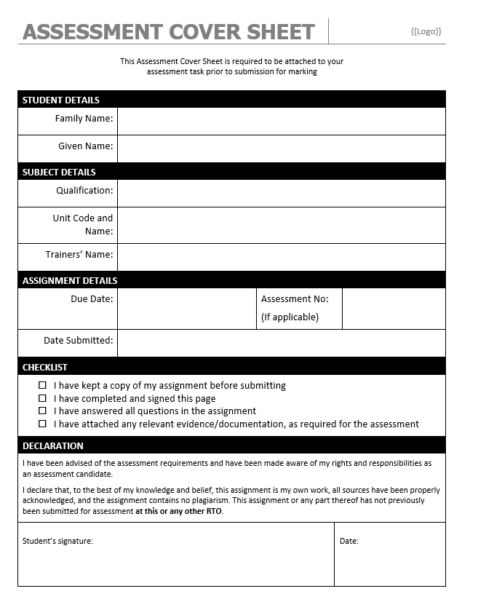

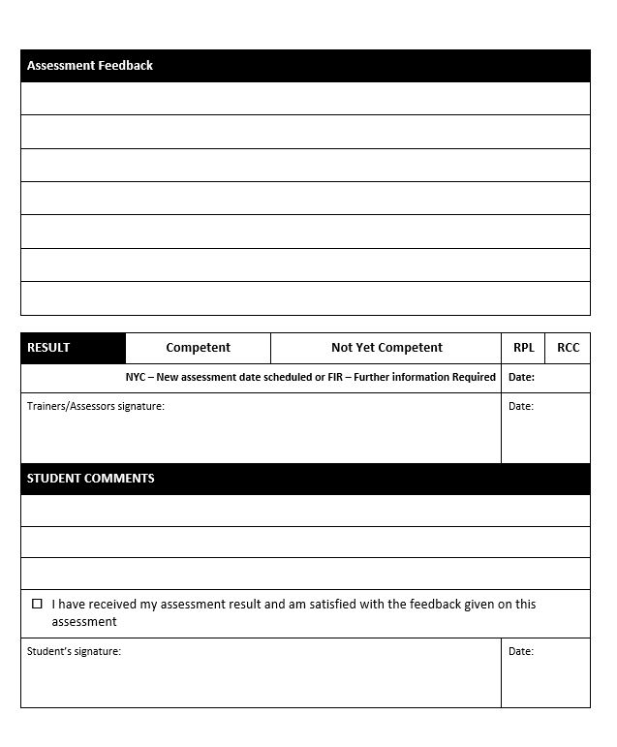

Complaints & Appeals Form
 | Complainant Name |  |  | COMPLAINT AGAINST  - Trainer  - Student  - RTO Staff Member  - Employer  - Resources  - Assessment Tools  - NSW Fishing Industry Training Committee Ltd
 | Date Submitted
 | Who is complaining  (Please tick) | - Student  - Trainer/Assessor | - RTO Staff Member  - Employer
 | Form submitted to
 | Other party/s involved
 | C&A Register No
Appeal’s must be lodged within 7 days of initial result being determined.
Refer to the Complaints & Appeals Policy in the Student Handbook for procedure.
DETAILS OF COMPLAINT/GREIVANCE/APPEAL
APPEALS: Have you discussed this matter with your trainer in an attempt to reach a decision? Yes/No
Complainant is given the opportunity to complete a Complaints Report Form, with this form, if there is not enough room on this form for the complaint. Complaints Form attached Yes/No
Signed By: Date:
- Form submitted to RTO Manager or CEO Date:________________
RECOMMENDED ACTION REQUIRED FOR IMPROVEMENT
Written Acknowledgement (within 5 business days)
- Written acknowledgement has been given to the complainant
Initial Meeting: (within 10 business days)
- Complaint raised
- Initial meeting held to discuss with all parties involved in the complaint, in order to find a solution agreeable to all parties.
- Solution found and remedied (Please continue to Appeal Outcomes section)
Further investigation required: (within 60 calendar days)
- Referral to RTO Manager or nominated person.
- Referred to a third party/panel
- Referral to other services (ie counselling services or LLN)
- Referred to National Training Complaints Hotline
- Referral to government body (ie police, hospital)
- Referral to funding body (ie DET, VTG)
The RTO is responsible for acting upon the subject of any complaint/appeal found to be substantiated.
APPEAL OUTCOMES
Action/Response Taken By: | Date:

FEEDBACK FROM COMPLAINANT
- Satisfied with outcome
- Dissatisfied with outcome – Further action required
- Matter was dealt with within a reasonable timeframe Yes/No
Other comment:
Complainant Signature: | Date:

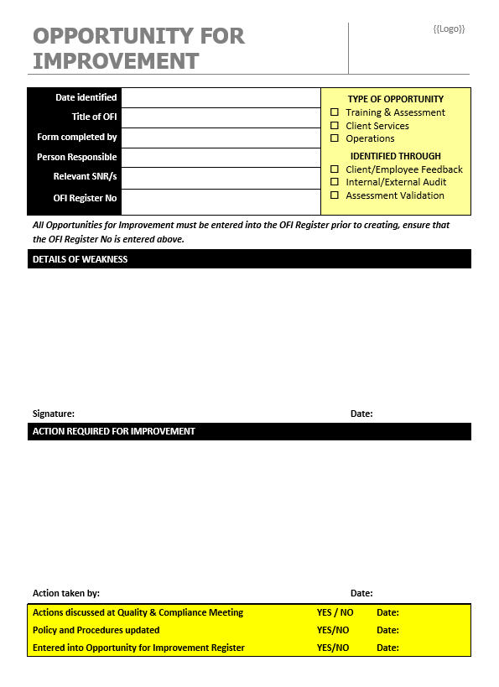

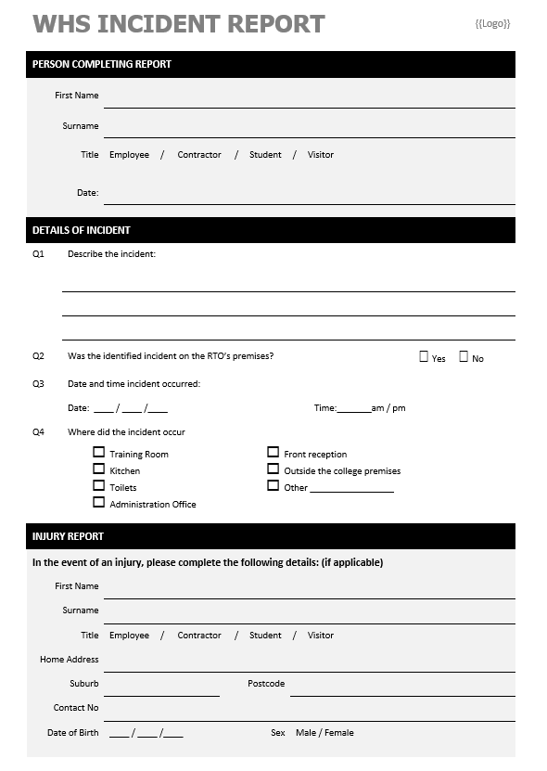

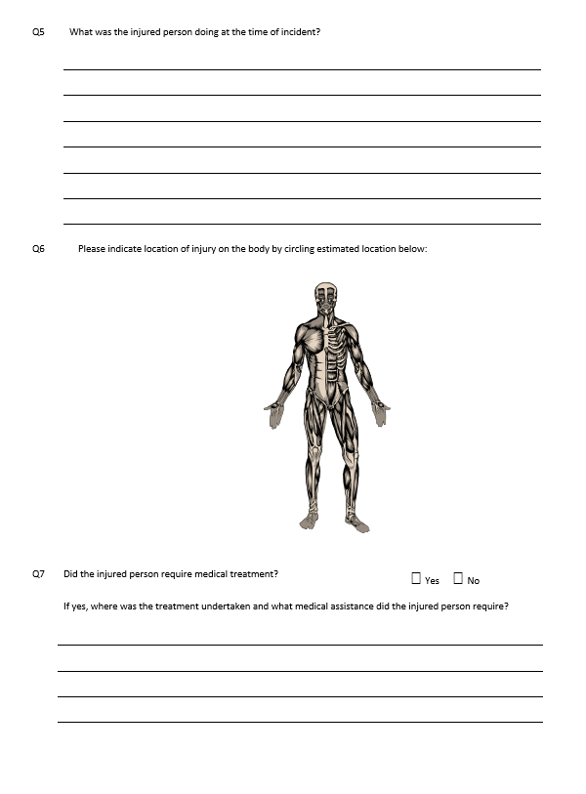

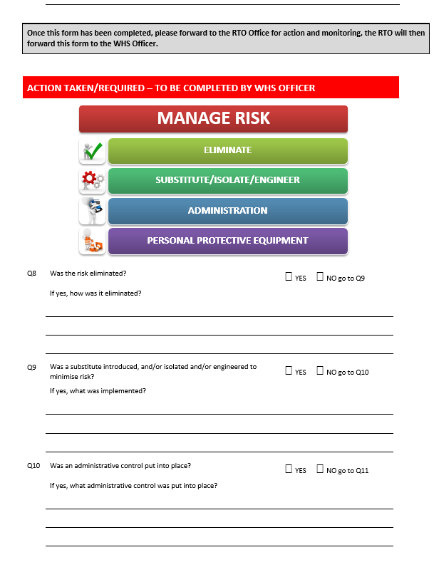

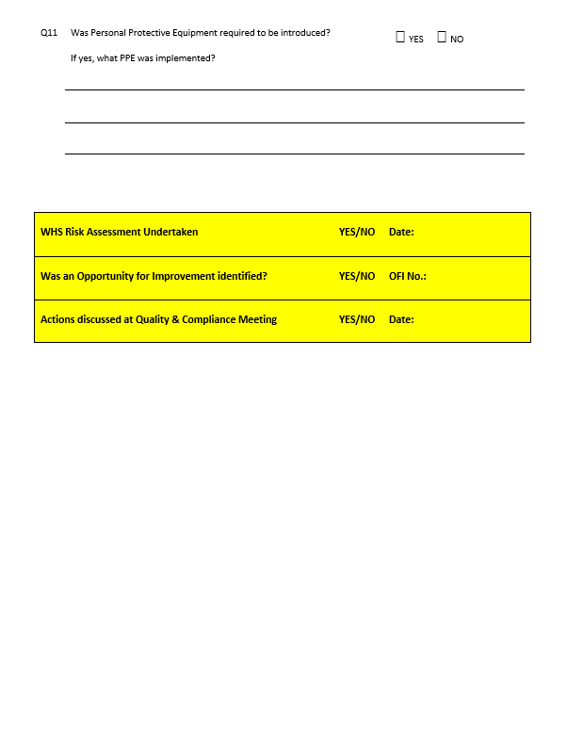

Support Services List
Name of Organisation | Website | Phone # | Email | Client Needs Addressed
AA - Alcoholics Anonymous | www.aa.org.au | 1300 222 222 | http://www.aa.org.au/contact-central-service-offices.php | Clients who are/or have been affected by alcoholism
Australia.gov.au | http://www.australia.gov.au/ | Website | Refer to Website | Covers a broad range of assistive support including LLN
Adult Migrant English Program | www.education.gov.au/adult-migrant-english-program-0 | 1300 566 046 | http://www.education.gov.au/feedback-and-enquiry-form | Assisting clients who have migrated to Australia and require assistance with LLN
Beyond Blue | www.beyondblue.org.au | 1300 224 636 | https://online.beyondblue.org.au/WebModules/Email/InitialInformation.aspx | For clients who are experiencing anxiety and/or depression
Black Dog Institute | www.blackdoginstitute.org.au | (02) 9382 2991 | http://www.blackdoginstitute.org.au/aboutus/contactus.cfm | Depression and Bipolar Disorder Information Australia
NSW Community Help | www.community.nsw.gov.au | 1300 555 727 | Refer to website | For clients who are experiencing difficulties in the home, domestic violence, child abuse and neglect
CEDD - Eating Disorder Help Centre | www.cedd.org.au | Refer to website | info@cedd.org.au | To assist clients who are experiencing issues with eating disorders
Kids Helpline | www.kidshelp.com.au | 1800 551 800 | Webchat or Email Available Online | Services for assisting children or people who are concerned about a child
Just Ask Us! | www.justaskus.org.au | 03 8413 8413 | http://www.turningpoint.org.au/About-Us/Contact-Us2.aspx | For clients who are concerned they may have a drug (incl. alcohol), emotional or mental health concern
Precision Consultancy | http://www.precisionconsultancy.com.au/acs_framework/ | 03 9606 0118 | http://www.precisionconsultancy.com.au/contact/ | Access to LLN assessment tasks that can be used for a variety of industries
Lifeline Australia | www.lifeline.org.au | 13 11 14 | https://www.lifeline.org.au/Get-Help/Online-Services/crisis-chat | Clients who may be in a crisis or at risk of suicide or know of someone at risk of suicide
The Reading Writing Hotline | http://readingwritinghotline.edu.au/ | 1300 655 506 | rwhotline@det.nsw.edu.au | If a client is having difficulty with reading, writing and numeracy
NA - Narcotics Anonymous | http://na.org.au/index.php?lang=en | 1300 652 820 | info@na.org.au | Clients who are/or have been affected by drugs
NSW Rape Crisis Centre | www.nswrapecrisis.com.au | 1800 424 017 | http://www.nswrapecrisis.com.au/GetHelp/NSWServices.aspx | To assist clients, and their non-offending supporters, who have experience or are at risk of sexual assault
Workplace Bullying Helpline | www.workershealth.com.au | 02 4926 2129 | newc.admin@workershealth.com.au | For clients who have been affected by bullying
Suicide Helpline | www.suicideline.org.au | 1300 651 251 | Available on website | For clients who may be contemplating suicide or don’t know how to help someone in their family who has been affected
Men’s Helpline Australia | https://www.mensline.org.au/ | 1300 78 99 78 |  | For male clients who have male related health issues
Wesley Mission | www.wesleymission.org.au | (02) 9263 5555 | Available on website | Helping people with a wide range of issues affecting communities and individuals.
National Council for Single Mothers and their Children | http://www.ncsmc.org.au/ | (08) 8354 3856 | ncsmc@ncsmc.org.au | Single mothers who need assistance
Physical disability Australia | http://www.pda.org.au/ | (02) 6567 1500 | Available on website | For clients who require assistance with their physical disability
Deaf Australia Translating and Interpreting Service | http://www.deafau.org.au/ | (07) 3357 8266 | Available on website | For assisting the trainer who might require an interpreter for clients who are deaf or have hearing impairments
Salvo Care Line | http://salvos.org.au/salvocareline/ | 1300 36 36 22 | Available on website | For clients who require financial assistance or emergency care
Disability Advocacy Network Aust. | http://www.dana.org.au/ | (02) 6175 1300 | Available on website | For clients who may require assistance with their disability
National Disability Service | http://www.nds.org.au/ | (02) 6283 3200 | nds@nds.org.au | For clients who may require assistance with their disability
Vision Australia | http://www.visionaustralia.org/ | 1300 84 74 66 | info@visionaustralia.org | For clients who require assistance due to vision impairment
Community Migrant Resource Centre | http://www.cmrc.com.au/ | (02) 9687 9907 | Available on website | For clients who may need assistance for Migration support services
Family and Community Services Ageing, Disability and Home Care | http://www.adhc.nsw.gov.au/ | (02) 9377 6000 | servicembx@facs.nsw.gov.au | Support for family, ageing, disability or home care
Job Access | https://www.jobaccess.gov.au/ | 1800 464 800 | hotline@workfocus.com | Driving Disability Employment through a variety of support services
Department of health/Mental health | www.health.gov.au | (02) 6289 1555 | Available on website | Support for students who are affected by health or mental health issues

